

INDUSTRIAL SURVEYING

3

3

3

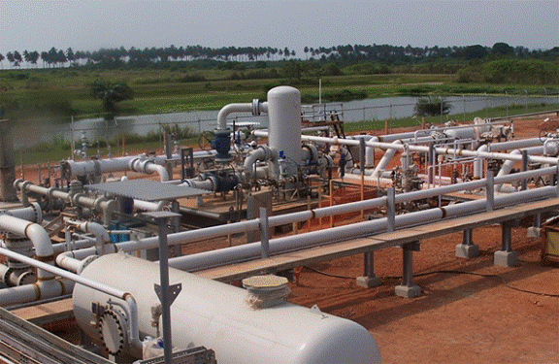F:\AKSM\Team_Gioula\diafora_gia_site\BROCHURES_YLIKO\paradosi_08282015\final_laser scanning & bim\photos\pg9_10\1.Ring.jpg**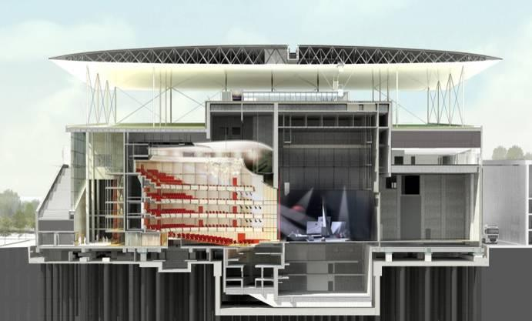**

**Construction and Geometric Verification of Opera’s Ferrocement Canopy Panels, Stavros Niarchos Foundation Cultural Centre, Athens, Greece**

* Creation of the 3D model of the panel
* Taking geometric information from the transverse and longitudinal sections at predetermined points
* Very high requirements of accuracy during the construction and checking of the panels – limit of 2mm
* Examination of the following data for geometric verification of each individual panel
* Distance between the ribs (vertical beams)
* Deviations of ribs axes
* Width of the ribs
* Distance between the beams
* Deviations of beams axes
* Width of the beams
* Flange thickness

**Façade As-Built Survey at C Ring – Doha, Qatar**

* Low time of data acquisition comparatively to the classical methods
* Non-invasive method to collect data
* Low price of works
* Authentic, full and accurate 3D copy of reality that cannot be executed with other measurement means or method
* 2D and 3D documentation within the easy reach of engineers, structure designers and architects
* Production of 2D drawings or 3D models for refurbishment and restoration project, compatible with all CAD software.

**Natural Gas Metering and Regulating Station – Takoradi, Ghana**

* Industrial surveying, design and construction support
* As-built information as a basis for the mechanical
* engineering team
* As-built for retrofit plant design (natural gas)
* Construction administration support for all civil works needed for this project
* Coordination in drawings in civil and mechanical works

6

PROJECTS

Surveying Precision

LASER SCANNING & BIM

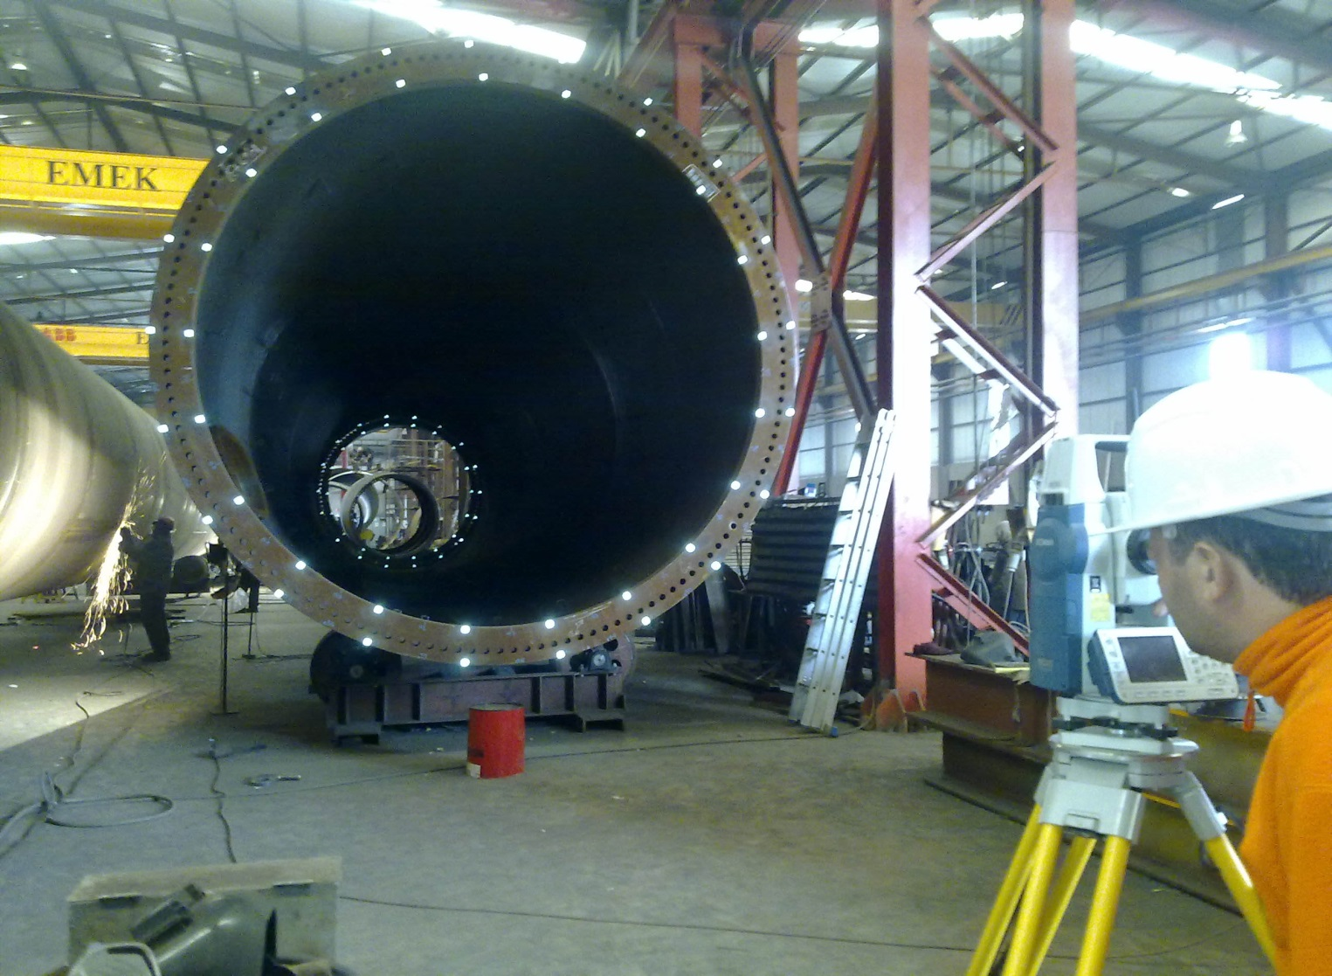



3

High Pressure Natural Gas and Regulating Station, Tema, Ghana

3

3

INDUSTRIAL SURVEYING

INDUSTRIAL SURVEYING

3



CIVIL SITES

**Applications**

* Topographic and structure surveys
* Roads, bridges, tunnels, rail, airports, power distribution, telecom
* Construction QA & monitoring
* 2D maps, 3D models, DTM’s
* Asset management, e.g. bridge clearances for truck route planning
* Topographic diagrams, site, planimetric surveys
* Commercial, public, residential properties
* 2D maps, DTM’s
* 3D scanning & 3D modeling of buildings, monuments constructions, objects
* Application studies & as built drawings
* Project supervision & project management
* Urban, environmental and hydraulic design
* Environmental impact design

**Applications**

* As-builts for retrofit plant design: oil & gas, petrochem, chemical, water, power and mineral
* Remote survey of difficult and dangerous nuclear, offshore and underground facilities
* QA check of fabricated parts against the design
* Construction and demolition planning
* Documentation for operations & maintenance

**Benefits**

* Faster, safer, less costly, more accurate, more

complete as-builts

* Reduces retrofit design & construction errors
* Reduces plant downtime from construction problems
* Faster, better retrofit design
* Reduces site visits & time on site for data capture
* Lets users leverage existing 3D design software for design and clash detection directly with scans

LASSER SCANNING & BIM

5

**Benefits**

* Faster, safer, less costly, more accurate, and more complete topographic & as-built survey
* Ability to re-use data instead of returning to the site for additional surveying
* Minimize road, airport, etc. closures for surveying and impact on site construction and site operations during surveying
* Ability to survey at night when site/asset may not be in use

HEAVY INDUSTRY

www.aksm.gr

Shipping Industry

SHIPPING INDUSTRY

**Applications**

* 2D and 3D as-builts of hull, frames, cabins, rooms and onboard plant & equipment for ship modifications and new construction
* Fabrication and construction QA
* Construction & installation planning
* Shaft alignment
* Merchant, military and leisure vessels

**Benefits**

* Faster, safer, less costly, more accurate, more complete as-builts
* Reduced refit design and construction errors
* Survey while at sea for parts fabrication pending arrival at base
* Virtual walkthrough for shore-based engineers
* Ability to re-use data instead of returning to the ship for additional surveying
* Ability to re-use data instead of returning to the ship for additional surveying

LASER SCANNING & BIM

5

www.aksm.gr